The Dentist’s Office Database

Evan Lysko and Michael Connelly

November 15th, 2020

Mike and Ev’s Database Design

Assistant Table

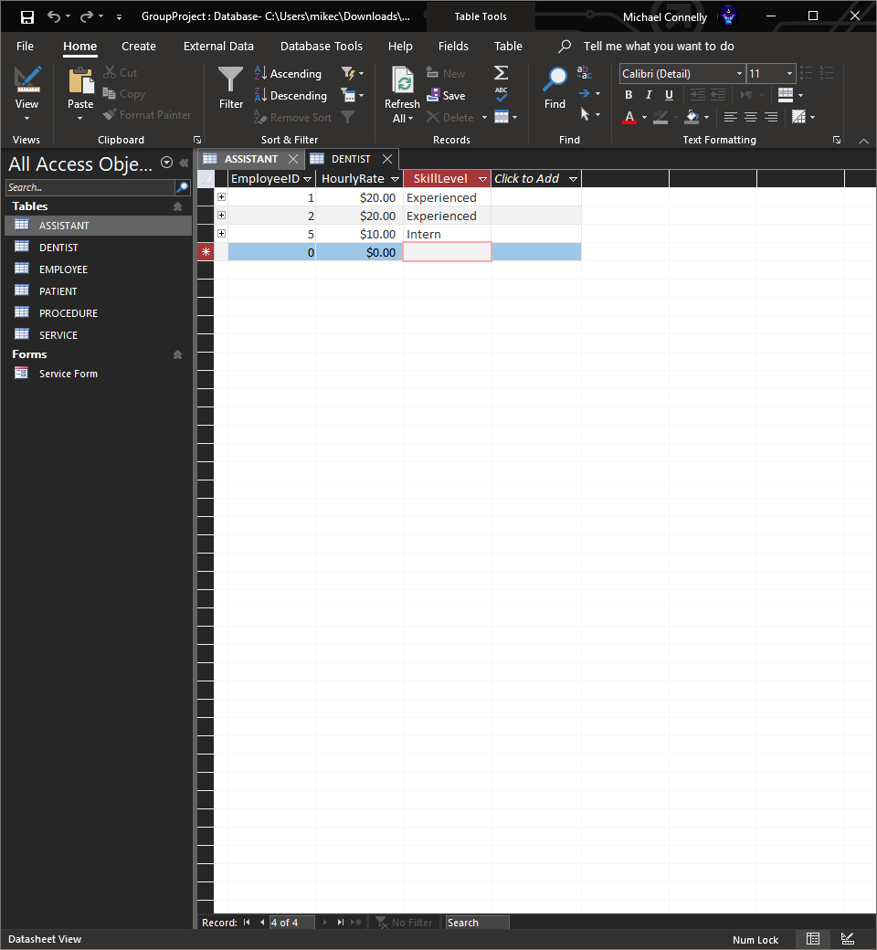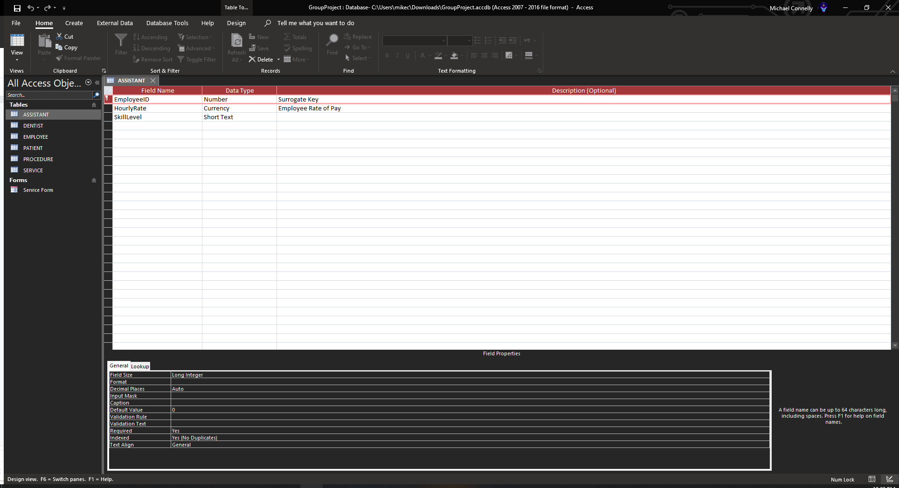

Dentist Table

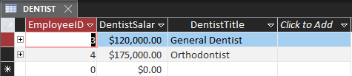

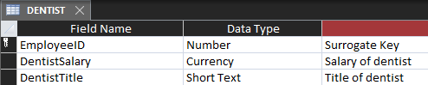

Employee Table

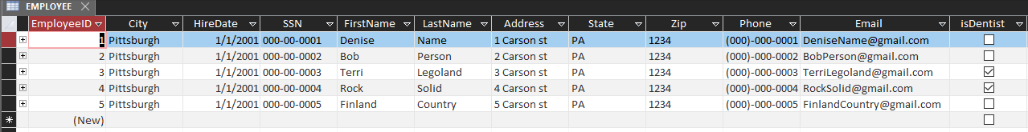

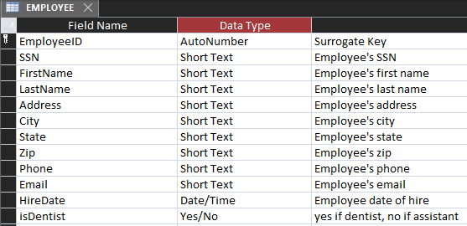

Patient Table

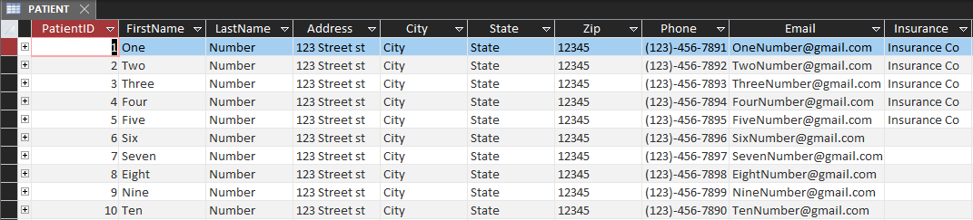

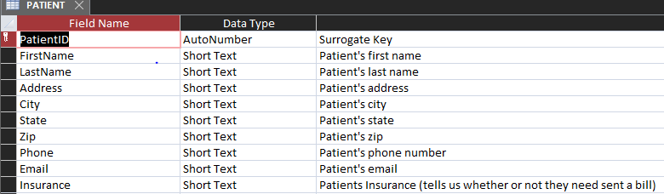

Procedure Table

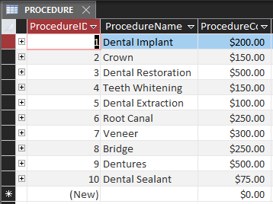

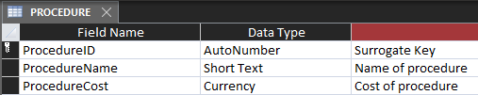

Service Table

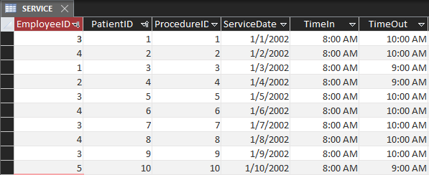

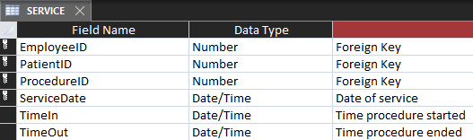

SQL Statements

MONTHLY BILL

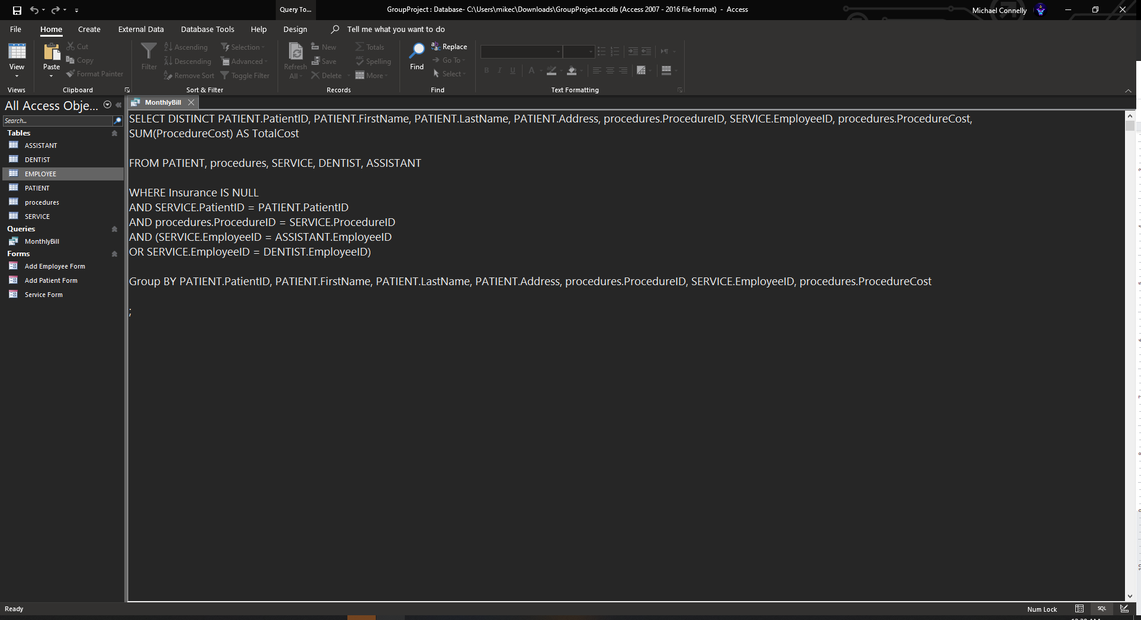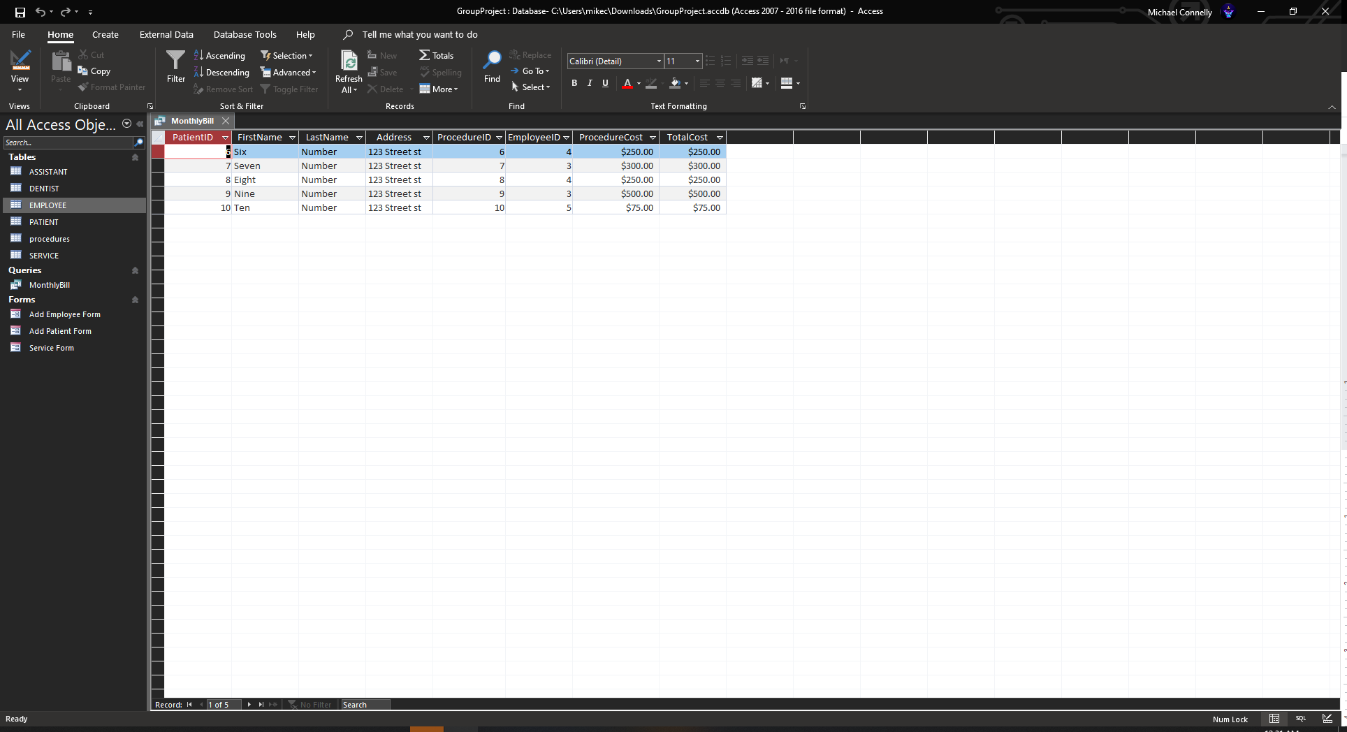

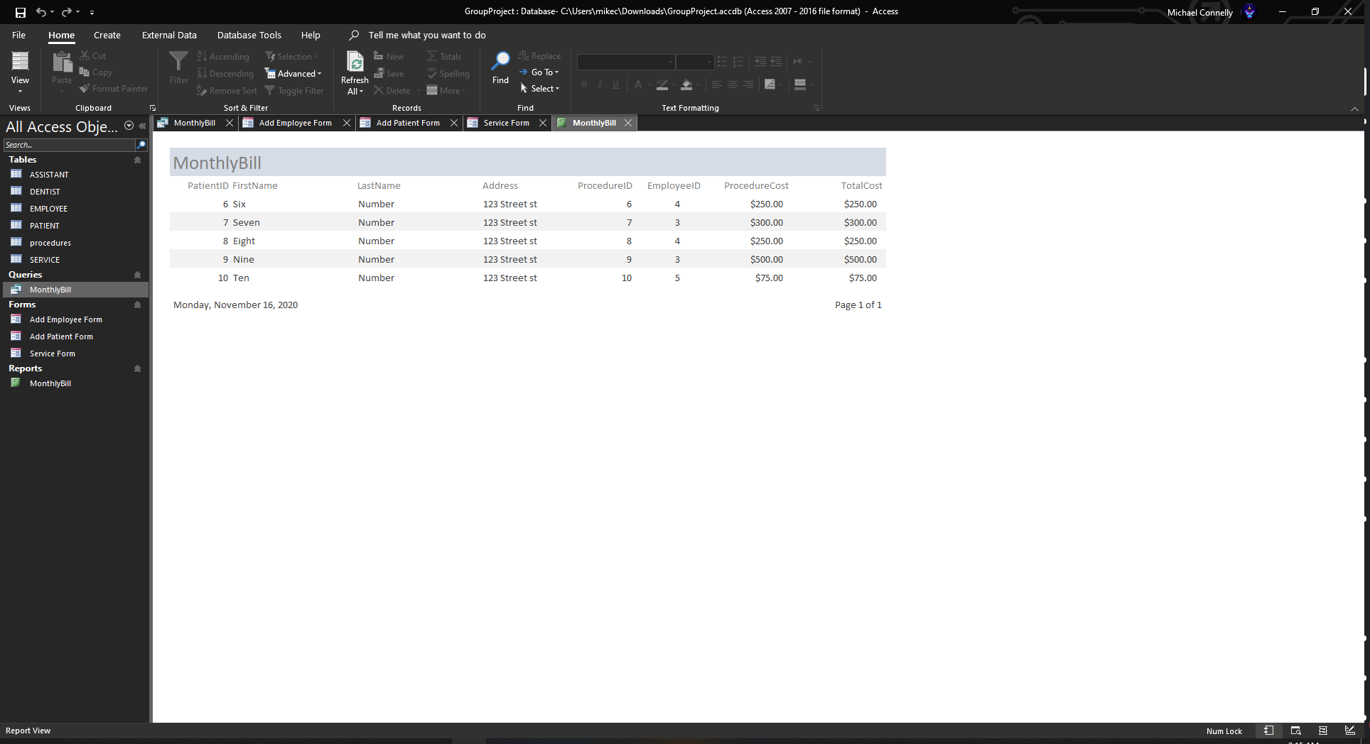

The monthly bill report generates the name and address of the patient, the procedures performed, the date of service, the service provider, the cost of each procedure, and the total bill.

MONTHLY PAYROLL

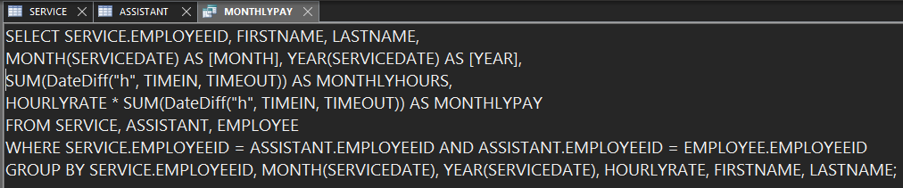

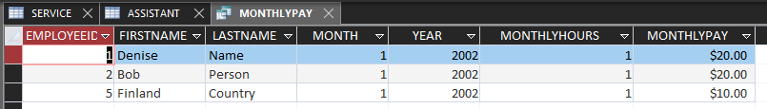

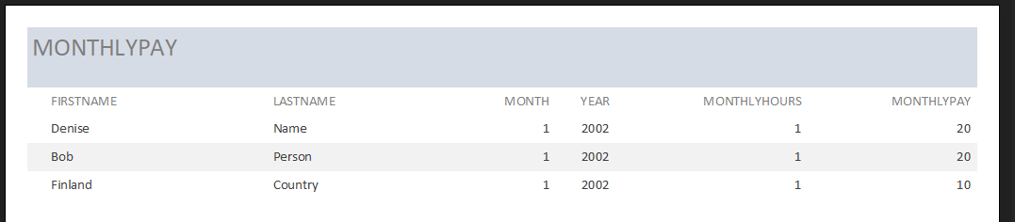

The monthly payroll report generates the EmployeeID, name of the assistant, month, year, hours worked that month, and finally their monthly pay.

Data Entry Forms

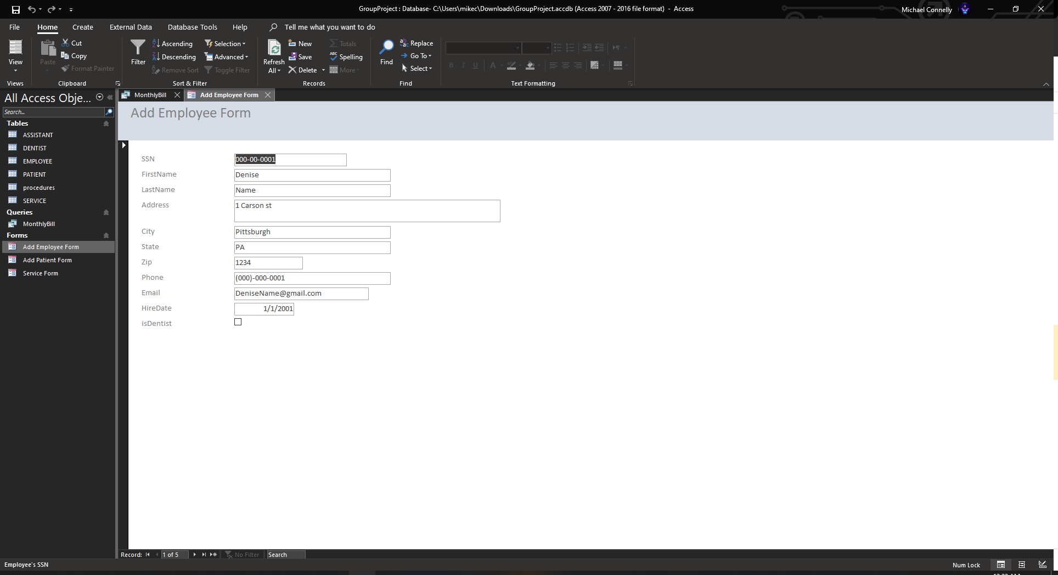

Add new employee info or edit existing employee info

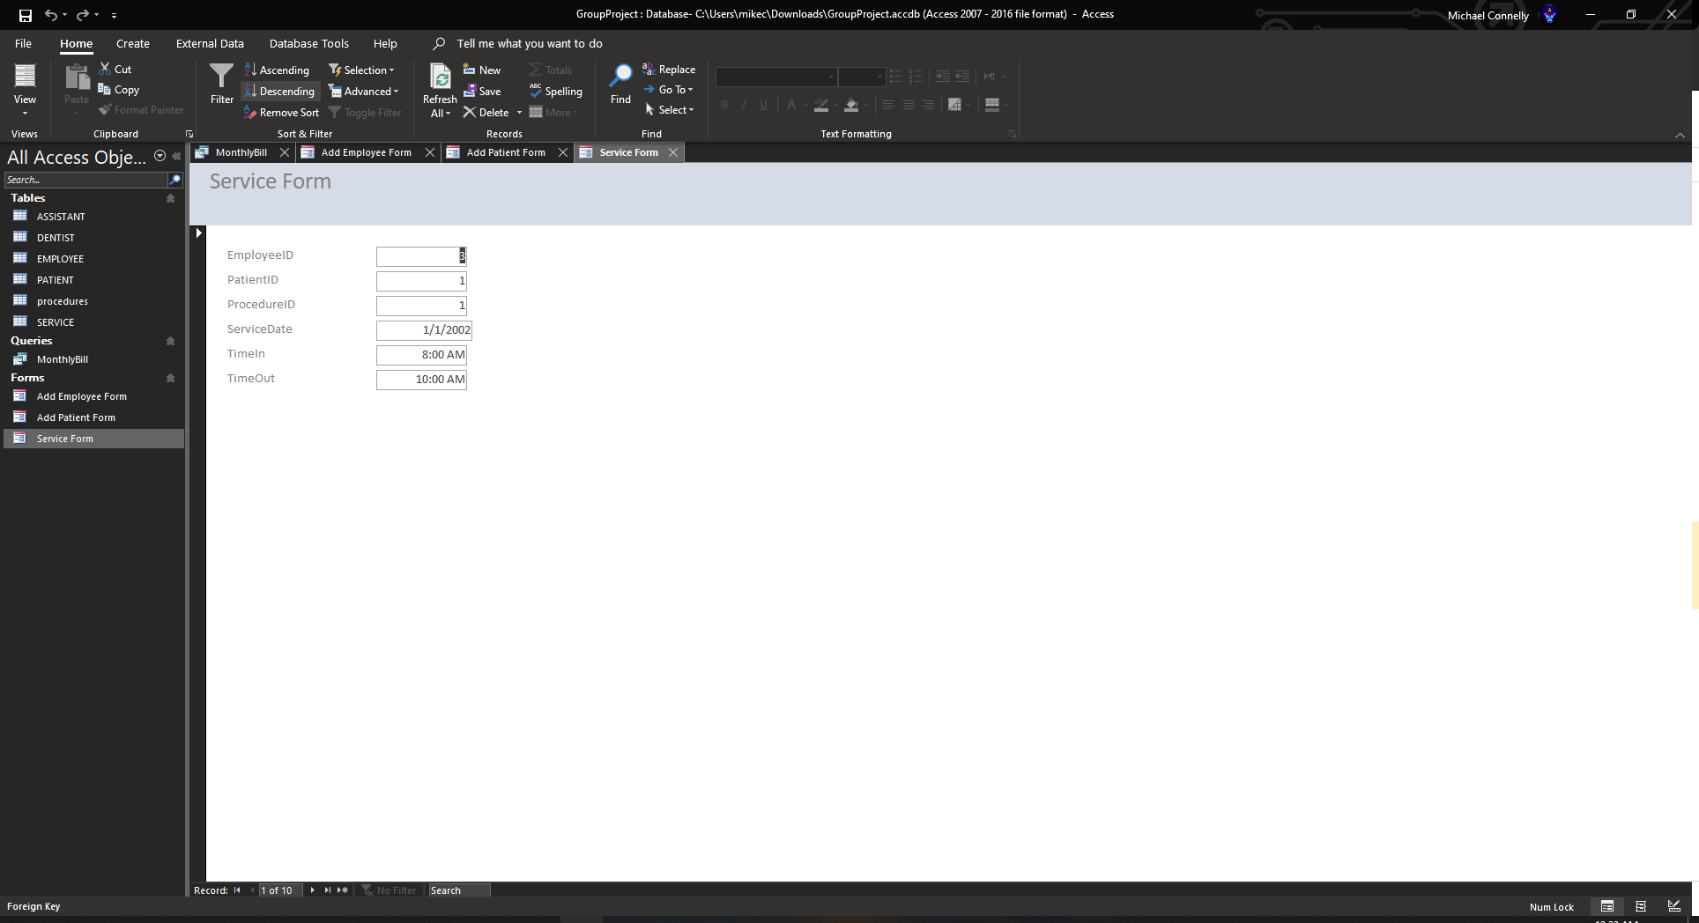

Schedule new services or edit existing services

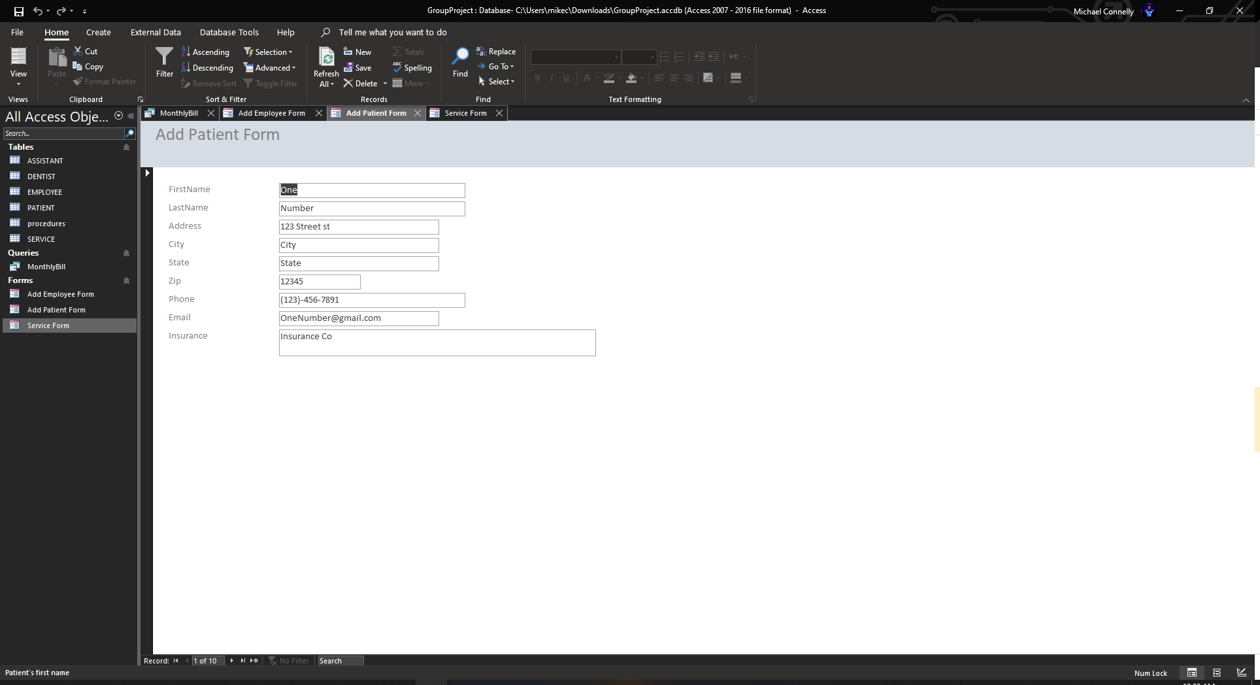

Add new patient info or edit existing patient info

Relationships Diagram